**Heaven’s Light is Our Guide**



**Rajshahi University of Engineering and Technology**

**Department of Computer Science and Engineering**

**Course No:** CSE.1204

**Course Title:** Sessional based on CSE.1203 (Object Oriented Programming)

**Lab Report No:** 04

**Lab Report On:** Use of File in Mobile Banking Apps.

**Submitted By** **Submitted To**

Md. Ariful Islam Md. Asifur Rahman

Roll No: 1803046 Lecturer

Section: A Dept. of CSE,RUET

Department: CSE

**Problem No:** 01

**Problem Statement:** Implementation of FILE in Rocket type Apps.

**Theory :** Many applications require that information be written to or read from an auxiliary memory device.Such information is stored on the memory device in the form of a **data file**.Thus,data files allow us to store information permanently, and to accessand alter that information whenever necessary.

In C++, files are mainly dealt by using ifstream, ofstream available in fstream headerfile.

**fstream :** Headerfile to both read and write from/to files.  
**ofstream :** To **write** on files.  
**ifstream :** To **read** from files.

Now the first step to open the particular file for read or write operation. We can write on files by **using “ofstream” function -**

ofstream obj;  
 obj.open(“filename”);

obj << “DATA”;

We can read from files by **using “ifstream” function -**

ifstream obj;  
 obj.open(“filename”);

obj >> “DATA”;

After reading from or writing to files we should close the files by “ **close ()** ” function to free the file pointer –

Obj.close ();

If we don’t close the file,next time when open that file the file pointer will be at where we last read or wrote.

**Source Code :**

|  |
| --- |
| #include<iostream>  #include<fstream>  #include<string.h>  using namespace std;  void menu()  {  cout<<"\tMENU\n1.Register\n2.Login\n0.Exit\n";  }  int main()  {  int a;  char id[12],pass[10],fname[20],f_id[12],f_pass[10];  menu();  cin>>a;  while(a!=0)  {  if(a==1)  {  cout<<"Enter ID: ";  cin>>id;  cout<<"Enter Password: ";  cin>>pass;  strcpy(fname,id);  strcat(fname,".txt");  ofstream obj1;  obj1.open(fname);  obj1<<id<<"\n"<<pass<<endl;  obj1.close();  cout<<"\nRegistration Successful...\n"<<endl;  menu();  cin>>a;  }  else if(a==2)  {  cout<<"Enter ID: ";  cin>>id;  cout<<"Enter Password: ";  cin>>pass;  strcpy(fname,id);  strcat(fname,".txt");  ifstream obj2;  obj2.open(fname);  if(obj2)  {  obj2>>f_id;  obj2>>f_pass;  if((strcmp(f_id,id)==0)&&(strcmp(f_pass,pass)==0))  {  cout<<"\nLogin Successful...\n"<<endl;  }  else  {  cout<<"\nInvalid ID or Password...\n"<<endl;  }  obj2.close();  menu();  cin>>a;  }  else  {  cout<<"\nInvalid Account ID...\n"<<endl;  menu();  cin>>a;  }  }  }  return 0;  } |

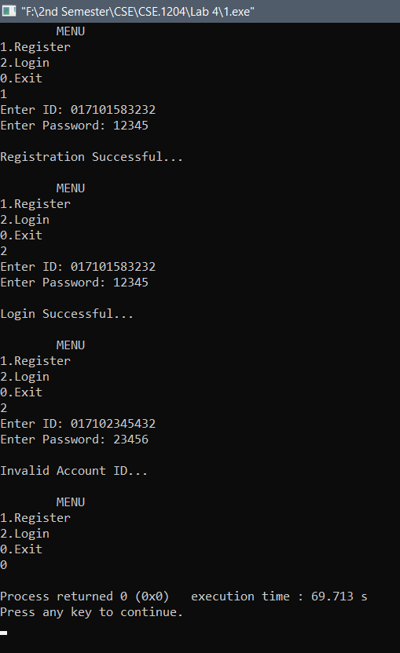**Output:**

**Conclusion :** By our Course Teachers help and my knowledge about C and C++, I completed the program.

**# The End #**